Name:_________________
Period:________________

Integration & Coordination
Ch. 9: The Nervous System

Introduction/General Functions
  - The nervous system provides
    - ______________________ [sens=feeling]-detects and gathers _________________ about the changes _______________ (i.e.: oxygen levels) and _________________ the body (i.e.: light, sound, temperature). Converts this information into ____________________ _________________.
    - __________________-ability to make decisions and act on them. Information brought ___________________ in the CNS.
    - _____________________- information from CNS to ______________________ (muscles/glands) and they respond.
  - The nervous system is composed of the
    - _______________ _______________ ______________ (CNS): brain & spinal cord.
    - ________________________ _________________ _______________________ (PNS): nerves.
- __________________________ Structure (____________ cells)
  - ___________ ___________: contains nucleus and organelles.
    - ______________________________-cytoplasmic threads that extend into the fibers.
    - ________________ ______________-similar to the Endoplasmic reticulum, __________________ attach to for ____________________________ synthesis.
  - _____________________ [dendr=tree] (many)-information brought _____________ the cell body. ____________________ surface of nerve fiber.
  - __________________ [ax=axle] (single)-information is taken ________________________ from the cell body.
    - In the PNS the axons are enclosed by a sheath of _____________________, this is produced by ____________________ cells that wrap around the axon.
    - In the myelin sheath are gaps/junctions called _____________ _________ _______________. The impulse “___________________” from node to node increasing the __________________ of the impulse.
    - In the CNS
      - White matter has a myelin sheath produced by ________________________________.
      - Gray matter is _______________________.
- Types of Neurons and Neuroglial cells
  - Structure of neurons:
    - ____________________-in eyes, nose, & ears
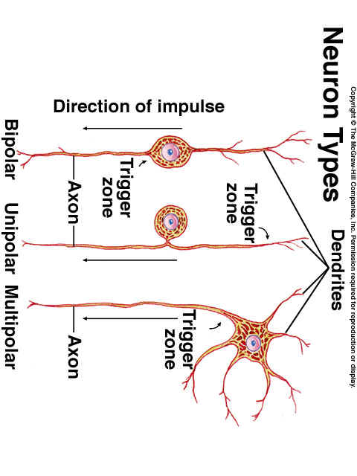
    - ____________________-in brain & spinal cord
    - ____________________- form masses called ___________________, found outside the brain & spinal cord.
  - Function of neurons:
    - ________________ neurons-{________________} ____________ PNS (information from the skin, senses, and receptors inside the body) to the CNS [unipolar, some bipolar].
    - ____________________-{_________________} from one part of the CNS to _______________ part of the CNS [multipolar].
    - _______________ neurons-{___________________} from the CNS to ________________, muscles/glands.
  - ___________________ cells (supporting cells around neurons).
    - ___________________-___________________ [cell clean-up].
    - ______________________________-form ________________ sheath in ____________.
    - __________________-near blood vessels and support structures, aid in metabolism, and form scar tissue after injury.
    - ______________________-line spaces within the CNS.
FYI
*________________________ cells=_________________ deprived cells b/c of lack of blood flow, causes irreversible changes in the neurons.
Infants nervous systems are underdeveloped b/c the __________________ sheaths are not completely grown.

Cell Membrane Potential
The neuron’s cell membrane is _________________- (electrically charged b/c of the _________________ distribution of the “+” and “-“ charges).
MORE NEGATIVE

K+
K+
K+

  - _________________________ POTENTIAL = potential difference (_________________________)
    - ________________________ (inside the cell):
MORE ________________________ b/c
      - Large negatively charged particles and proteins-________________ diffuse across the membrane.
      - Higher concentration of potassium (K⁺) __________________ the cell.
    - _________________________ (outside the cell):
MORE ________________________ b/c
      - _____________________ concentration of Na⁺ outside the cell. [K⁺ diffuses out and is pumped back in (by ____________ _____________).]
  - __________________________ = potential changes
i. A ____________________ (responds to changes: temperature, light, pressure) occurs and affects the ___________________ potential of the membrane: the membrane becomes _____________ negative = ____________________________.
- _______________________ potential: the adding up (summation) of a stimulus. Once the threshold is reached an ___________________ ________________ occurs.
MORE POSITIVE

Sodium IN

  - ACTION POTENTIAL
    - The membrane’s permeability to ______________________ changes in the region of the stimulus.
    - Intracellular ________________________
Becomes _________________ POSITVE b/c
      - Na⁺ channels _______________: the Na⁺ diffuses ____________, also helping is that “-“ attracts the “+”.
Potassium OUT
MORE NEGATIVE

Region of REPOLARIZATION
    - At about the same time the K+ ions diffuse _________________ causing the inside to become _________________ NEGATIVE
= _______________________________.
    - The ________________________ pump ___________________ transports the Na⁺ back outside and the K⁺ inside, restoring the ______________________ concentrations = ____________________ (resting potential). The inside is __________________________ NEGATIVE.

FYI: Local anesthetic drugs ________________________ the membrane permeability to Na+, impulse cannot pass, no information to the brain=NO PAIN.

V. Nerve Impulse
The action potential in one region _________________ the adjacent region causing a __________ of action potentials to move down the fiber.
a. Impulse conduction
______________________________ fibers conduct the impulse over the entire surface (slower).
________________________ fibers impulses “jump” from node to node __________________ conduction). Impulse is __________________________.
b. All-or-None Response
When the _________________________ for the action potential is reached the nerve will respond _____________________.

VI. The Synapse…
-is the __________________ between two neurons.
There is a ______________________(gap) that separates the two neurons and the impulse has to get across it to pass the stimulus along.

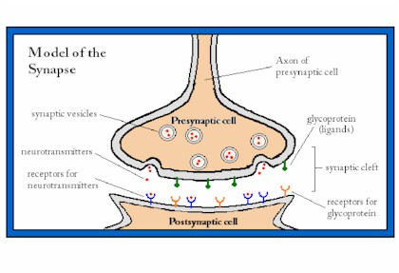
AXON of presynaptic cell
Receptive surface of postsynaptic cell
RECEPTORS
NEUROTRANSMITTERS
SYNAPTIC VESICLES
SYNAPTIC CLEFT (GAP)

- Synaptic Transmission
- See diagram and listen to the explanation!!
- Excitatory and Inhibitory Actions
  - __________________________ neurotransmitters ___________________ the postsynaptic membrane permeability to ___________, increasing the chances that the threshold will be reached and pass the impulse along.
  - ____________________ neurotransmitters ___________________ the postsynaptic membrane permeability to _____________, decreasing the chances that the threshold will be reached, therefore _________ impulse.
- Neurotransmitters
  - About 50 types of neurotransmitters are produced and stored in the __________________ ________________.
  - When an action potential reaches the end, the synaptic vesicles ___________ with the membrane (____________) and release their chemicals across the cleft.
  - To stop the impulse/stimulation
    - __________________ will either
      - _______________________ the neurotransmitters or
      - _____________________ them.
    - _________________________: the neurotransmitters are ______________________ ________ into their synaptic vesicles.

VII. Types of Nerves
a. A ___________________ is a ______________________ of nerve fibers held together by connective tissue.
b. Types of nerves:
i. ________________________ - ______ the CNS
ii. ____________ - from CNS to ______________ (muscles/glands)
iii. _________________ - carry __________________ sensory & motor nerves.

VIII. Nerve Pathways
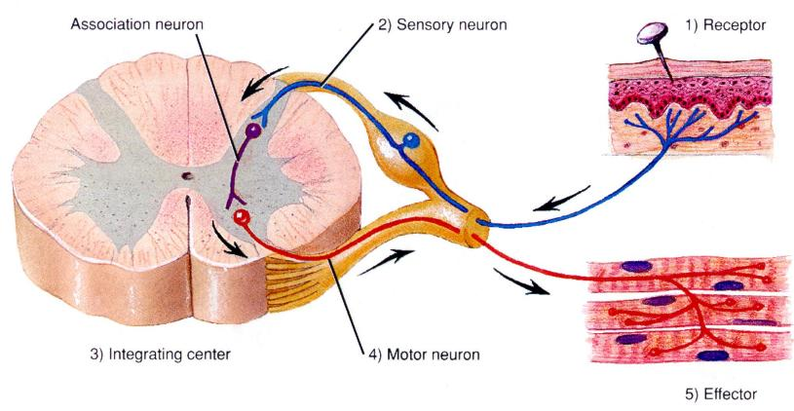
4. Motor Neuron
2. Sensory Neuron
3. Interneuron
1. Receptor
5. Effectors
Cross section of spinal cord
Skin
Muscle

a. _____________________ _____________
i. The ___________________ of nerve pathways.
ii. Parts:
1. _____________________ receptor-picks up information
2. _____________________-in the spinal cord, processes information (________________ center) and sends it to
3. ____________________ neuron-from CNS to effectors, elicit response.
iii. Reflex behavior
1. Reflexes help to maintain ___________________.
a. ______________________ processes
i. _______________ rate
ii. _____________________ rate
iii. ______________ _____________
iv. Digestion
b. _____________________ actions
i. Swallowing
ii. Sneezing
iii. Coughing
iv. _______________________
2. Types
a. ____________-____________ reflex: sensory and motor neurons only. Helps to maintain _______________, by contracting quadriceps femoris.
b. __________________ reflex: Protective response
i. _________________ picks up the information and sends it to an _______________________.
ii. _________________-1st message sent to a _________________ neuron, to move the muscle, then a 2nd message is sent on another ________________ to the ________________ for pain.
Revised 12-08

