Name ________________
Period ________________
CHAPTER 11
THE ENDOCRINE SYSTEM

- Introduction
  - The body has 2 types of ________________________
    - ________________________: fluids released ______________ a duct. (examples: sweat glands & salivary glands)
    - ___________________: ____________________ released into the bloodstream. (________________)
  - The __________________ system and _________________ system coordinate functions in the body.
    - The nervous system can ___________________ or ________________ the release of _______________.
    - _____________________ can promote or inhibit ____________________________ impulses.
    - Nerve impulses occur within ____________________.
    - Hormonal responses are released __________________ and the effects can last ______________________, even days.
- General Characteristics of the Endocrine System
  - Hormones regulate ____________________ activities (___________________), regulate _________________ and development, and guide ________________________.
  - The endocrine glands are located through out the ______________________ and in ____________________ of several organs. (Examples: stomach, skin, & heart)
- Hormone Action
  - A hormone is a _________________________ ______________ that has affects on __________________ cells called, _____________________ ______________.
    - Target cells have specific _________________ sites (_________________________) for the hormones to bind to.

- Hormone types
    - ___________________________ Hormones
      - Made from ___________________ (a lipid) therefore they are _______________________ and can pass through the __________ ______________.
      - Their receptor site is located _________ the target cell’s ______________________.
      - Once inside it _______________ w/_____________ and activates ___________________ ______________ of specific proteins.
      - The ____________ proteins alter the cell’s activity and cause the ___________________ of that hormone.
      - Examples are the sex hormones; __________________ and ________________.
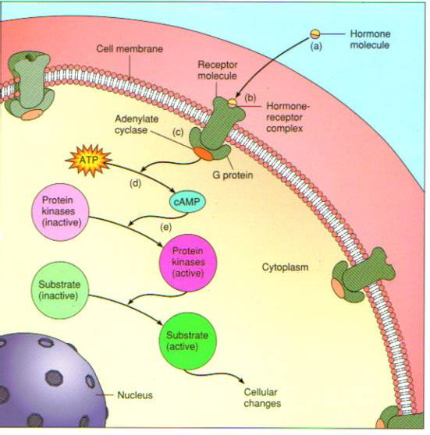
    - Amines, peptides, and proteins
      - Made from _______________ _____________.
      - Their receptor site is located ____________ the cell’s _____________________. (These hormones __________________________ get in through the plasma membrane.)
      - The ___________________________ _____________, the first messenger, activates a ________________ messenger (usually_______________; made from the breakdown of _____________) in the ____________________.
      - The second messenger promotes a series of _________________ leading to ___________________ within the _________________ _______________.
    - ___________________ & ___________________
      - _____________________ based molecule.
      - Effects are _____________, often to the _________________ in which they were produced.
      - Effects include: relaxing/contacting ________________ __________________ of the air ways and blood vessels, ______________________ of other hormones, influence of blood pressure, and _________________________.
- Control of Hormonal Secretions
  - ___________________ ________________ ___________ (the _______________ step in a series of events ________________the _________________ step).
(Fig. 11.4)
    - Gland A ___________________ hormone A into the ___________________, which ______________________ the secretion of hormone B from __________________ B.
    - Gland B releases its ___________________ B into the __________________________:
      - Hormone B travels to the target _______________ on the target ______________ = ______________ of the target _____________________.
      - Hormone B also travels ____________ to Gland A and __________________ it due to its _________________ ___________________.
    - Gland A now ______________ sending hormone A to gland B, eventually the ____________ levels of hormone B will _______________ Gland A and the cycle _____________________.
  - Control Sources
    - The __________________________ [Master Gland] (link between nervous & endocrine) controls the _________________ ______________ Gland. The Ant. Pituitary Gland, in turn, ___________________ other endocrine glands.
    - The ____________________ system directly controls certain glands.
    - Some glands respond _______________________ to changes in the internal environment.
The Glands
Pituitary Gland
- Anterior and Posterior Lobes
- Attached to _____________________________
- _______________________________ lobe
- Hormones:
- ______________________________________: stimulates the size and division of body cells
- _________________________: Stimulates production and secretion of milk
- __________________________________________________: stimulates thyroid gland
- _________________________________________________& ________________________________________________
- Males: ________________________ production
- Females: stimulates _____________________
- Posterior Lobe
- Hormones
- ______________________________________: regulates water concentrations
- ___________________________: Stimulates uterine contractions and milk ejection
Thyroid Gland
- Hormones
- __________________ (tetraidothyronine) T₄ & ___________________________________ T₃ [5X more potent]
- Maintains _______________________ activities: increases; the rate of energy released from ________________________, protein _______________________, and the activity of the nervous system, and accelerates __________________________.
- Controlled by TSH (_______________________________) from the Anterior Pituitary

-_____________________________________
    - Lowers blood _________________________ and phosphate ion levels by inhibiting __________________________ from ___________________________.
    - Controlled by _____________________ levels in ____________________.
Parathyroid Glands
- Hormones
- _________________________________ hormones (PTH):
- ___________________________ the release of calcium levels in the blood.
- Controlled by Calcium levels in blood.
Pancreas
- ___________________________________: digestion
- _________________________________________: hormones
- ______________________________________
- Stimulates the _______________________ to breakdown _________________________ into glucose. [______________________ blood glucose levels.]
-__________________________________
- Stimulates the liver to _________________ glycogen from glucose. [_____________________ blood glucose levels.]
*Both are controlled by the levels of _________________ in the blood.
Adrenal gland
- Adrenal __________________________ (inner portion)
- Hormones “Fight or Flight”
- Epinephrine (__________________) & Noriepinephrine (_____________________________)
- _____________________________; heart rate, force of contraction, breathing, blood pressure, and _________________________ digestion.
- Controlled by ___________________________ system.

- Adrenal __________________________ (outer portion)
- Hormones (30 vital)
- ________________________________
- maintains __________________ volume and pressure by allowing the _____________________ to conserve Sodium and excrete Potassium.
- Controlled by __________________________
- _______________________________
- Affect ______________________________ of carbohydrates, proteins, and lipids.
- Controlled by _____________ (adrenocorticotropic hormone)
Pineal Gland
- Hormone
- ____________________________
- Regulates _________________ (sleep/wake) patterns
- Controlled by _________________________ patterns
Thymus Gland
- Larger in children, _________________________ over time.
- Functions with the __________________________ system.
Reproductive Hormones
- Female
- Hormones from ___________________________
- _______________________________
- ______________________ sex characteristics and buildup of _____________________ lining
- Controlled by ____________________

- ___________________________________
- _____________________ of uterine lining
- Controlled by ________________
- Male
- Hormones from __________________________
- _____________________________________
- Promotes the development of sperm and maintains secondary sex characteristics

Revised 2-09

